On December 13, 2025, Galgotias University hosted an intensive one-day online workshop titled "Hands-On With NVIDIA: Fundamentals of Deep Learning." This session was designed to bridge the gap between theoretical AI concepts and real-world application, utilizing NVIDIA’s industry-standard software environment.
Participants explored the core mechanics of neural networks, gaining practical experience in:
Data Augmentation: Techniques to improve model robustness.
Neural Network Architecture: Building and training models from scratch.
Transfer Learning: Leveraging pre-trained models to accelerate development.
The workshop emphasized a "learn-by-doing" approach, where attendees used NVIDIA GPU-accelerated containers to solve complex computer vision and data processing tasks. By the end of the session, students and professionals alike were equipped to implement deep learning workflows, earning a recognized competency in the foundational tools driving the modern AI revolution.
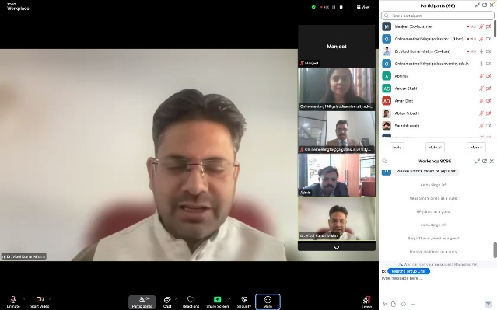
#DeepLearning #NVIDIA #GalgotiasUniversity #ArtificialIntelligence #TechWorkshop #HandsOnLearning #NeuralNetworks #FutureOfAI

